- Home Page: displaying customer list

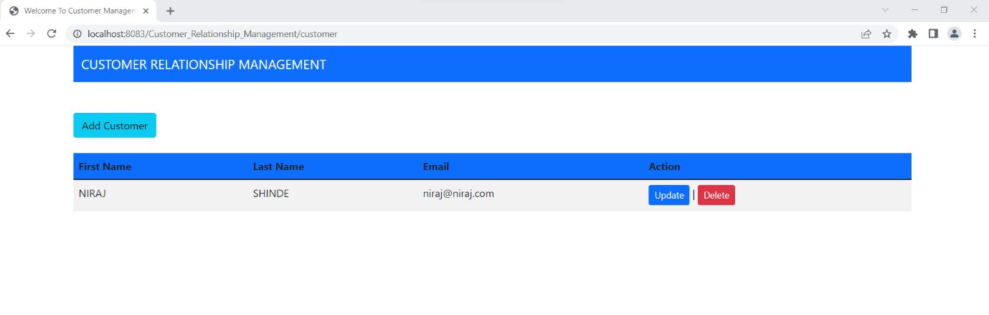
- Add Customer:

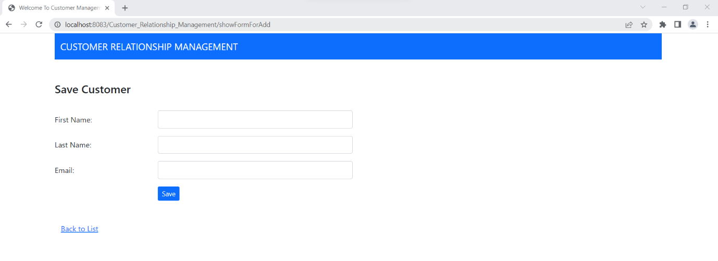
- Server-Side Validation:

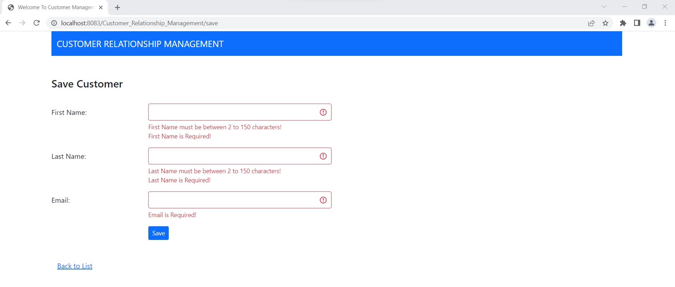

- Email Validation:

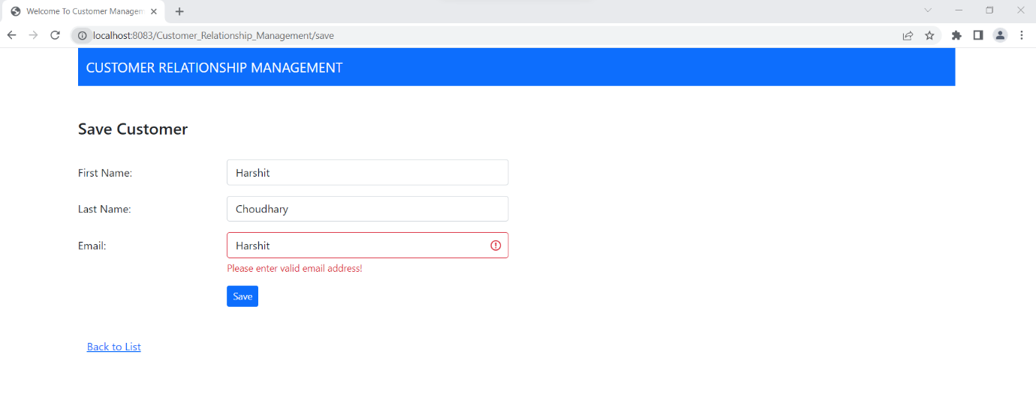

- After successfully Adding customer user will redirect back to home page:

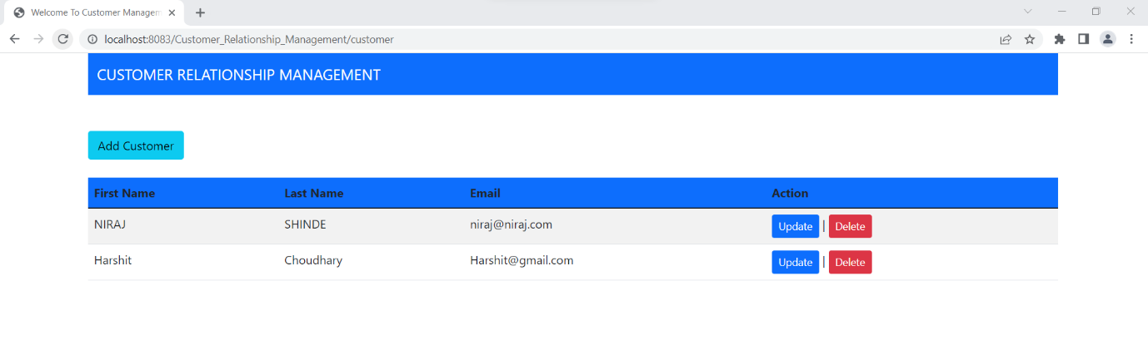
- Edit Customer Details:

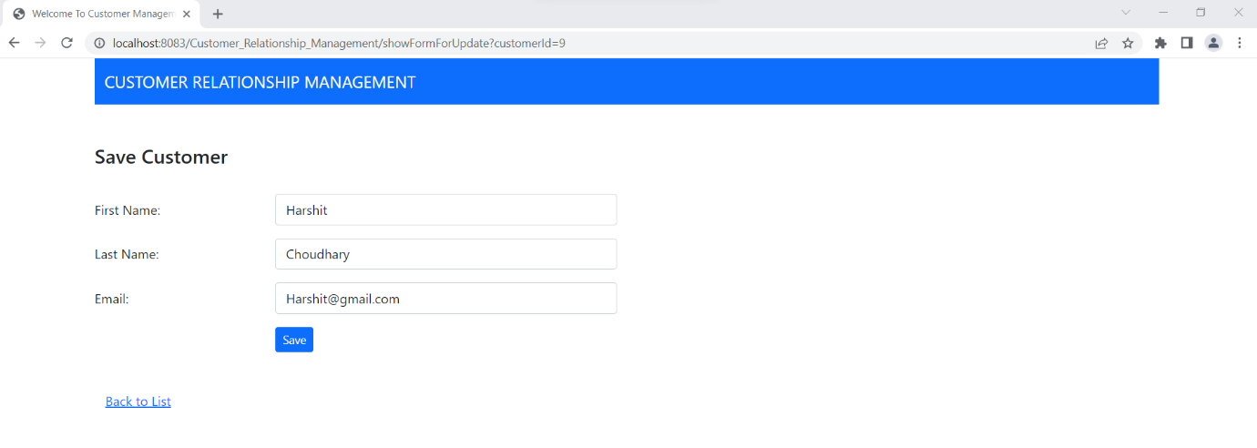

- Delete confirmation Message:

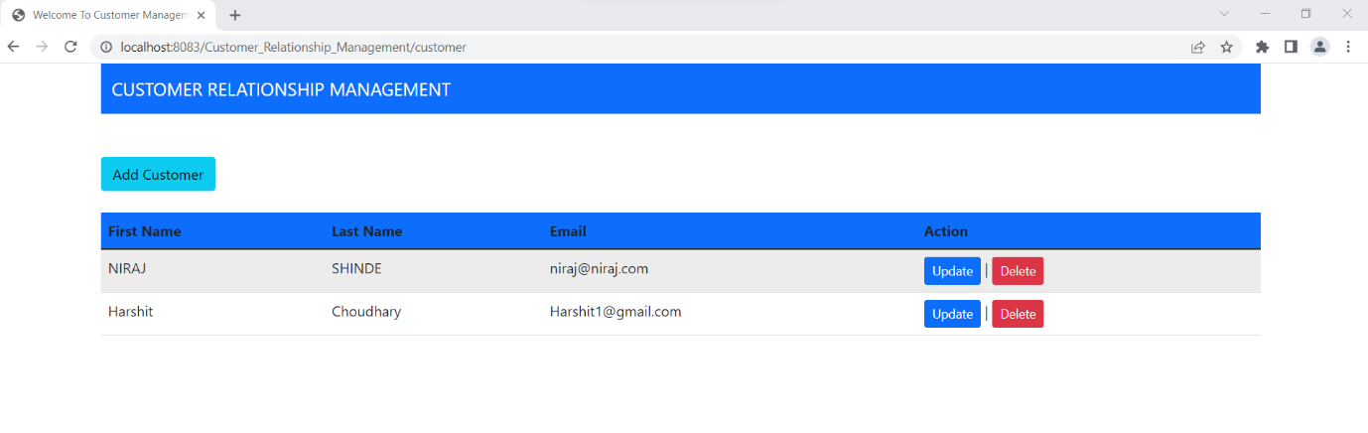
- Delete confirmation Message:

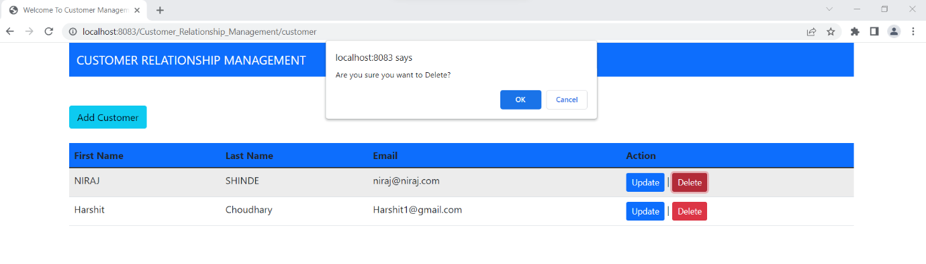
- When user clicks Ok in above confirmation message customer details gets deleted:

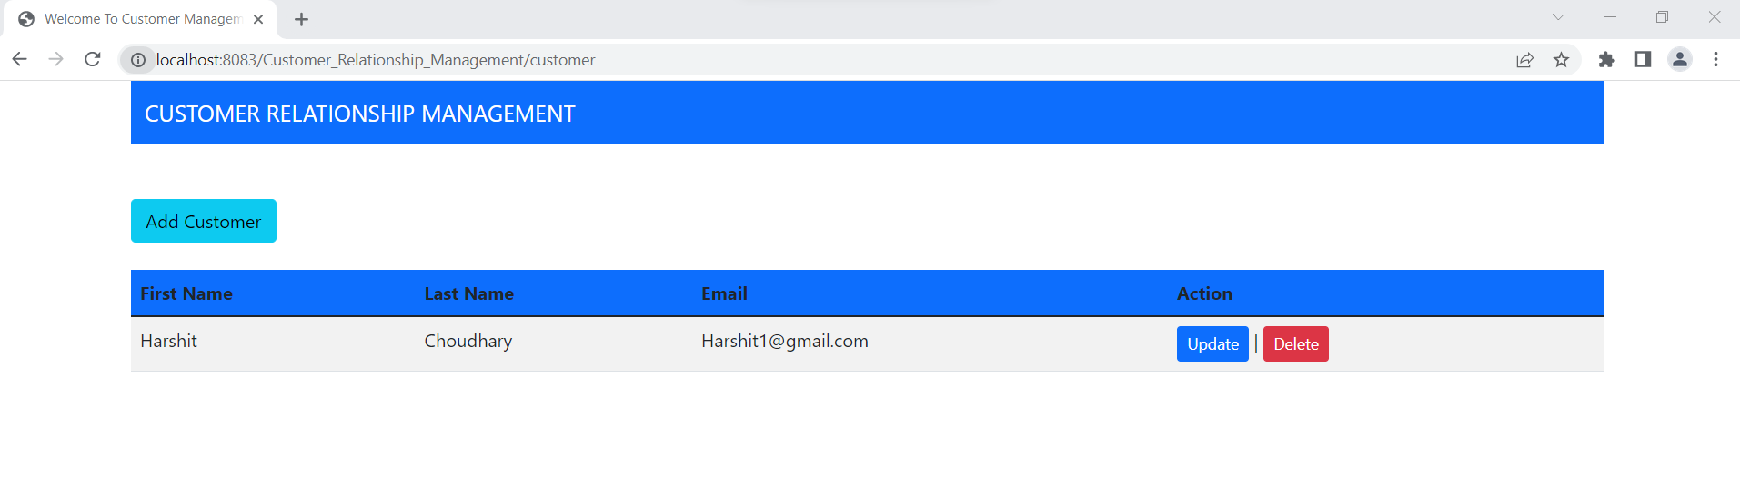
- Generalised error message page to redirect user to error page when any error happens in website, below is screenshot of 404 error
